In-class ITC 240 June 3, 2014

* Architecture
* Functions

Start at the database – create the table for the project

It helps to have dummy data

Solve one problem at a time – restrict the issues and do them one at time

1. Make the database, add dummy data to it….why?
2. Show database (SHOW)
3. Make the database sort (ORDER BY)
4. Save our sort (option ----cookie)
   1. “If “statement
5. Use the cookie to sort

Pina Colada

GF Cherries Jubilee

Strawberry Lemonade

Carrot Walnut

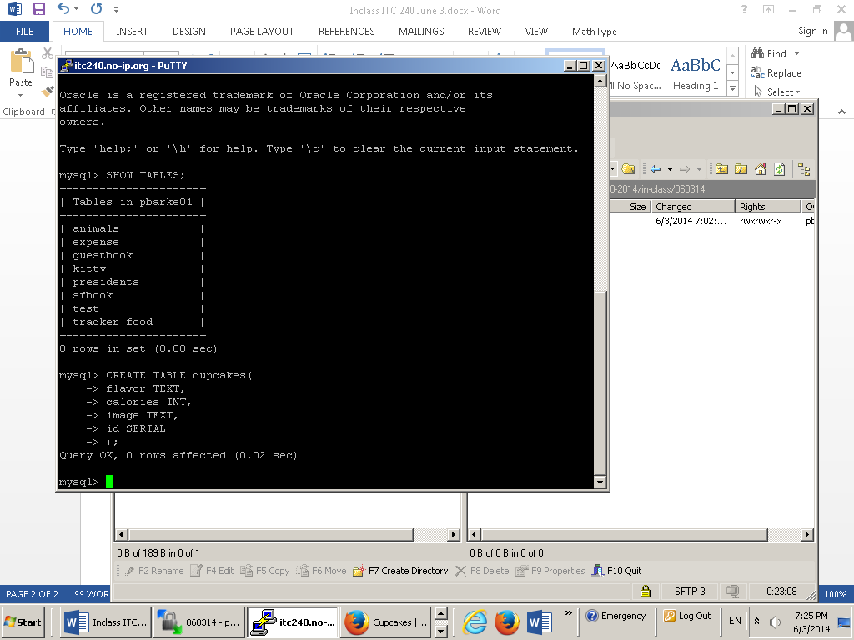

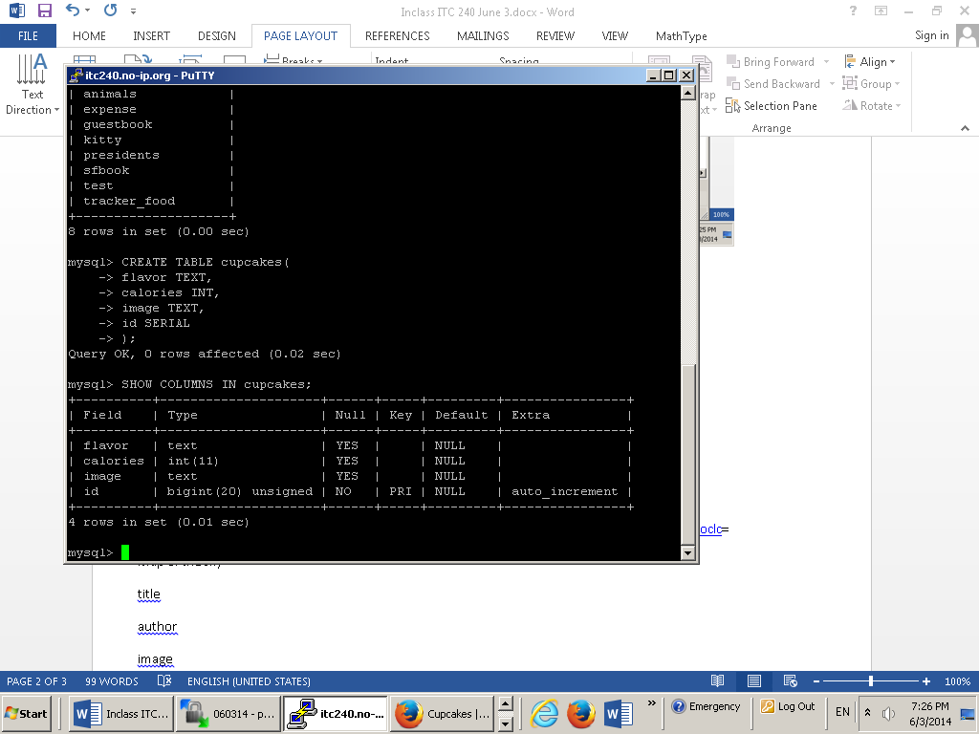

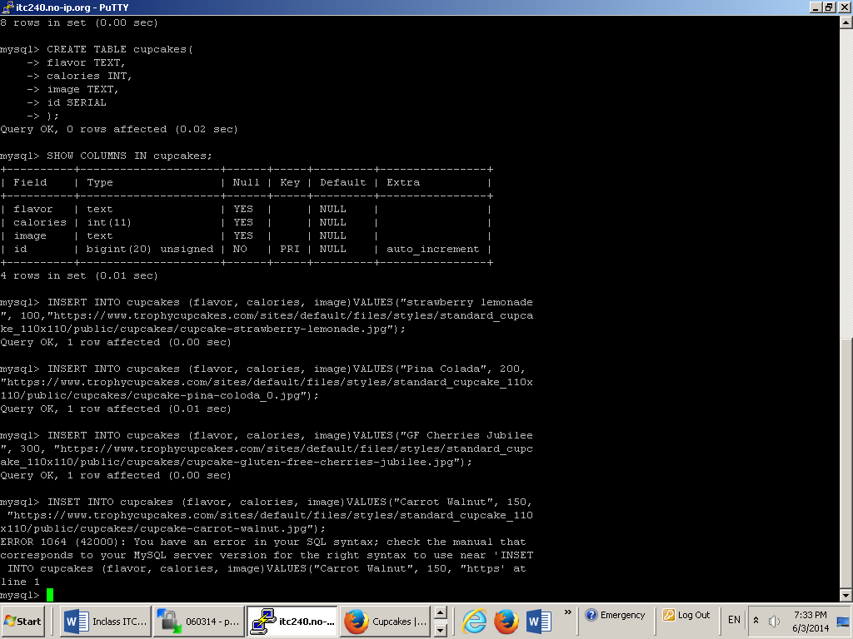

* Include passwords.php
* $mysql connection
* Select cupcakes
* Loop through them
* Set the default
* Check the cookie
* Check the request

Lets make a function - define before use – put at the top

Functions have inputs(name and a default) and returns an output (output is always a value)

get_option function should be able to accept the name of an option and the default we want if it can’t find the option